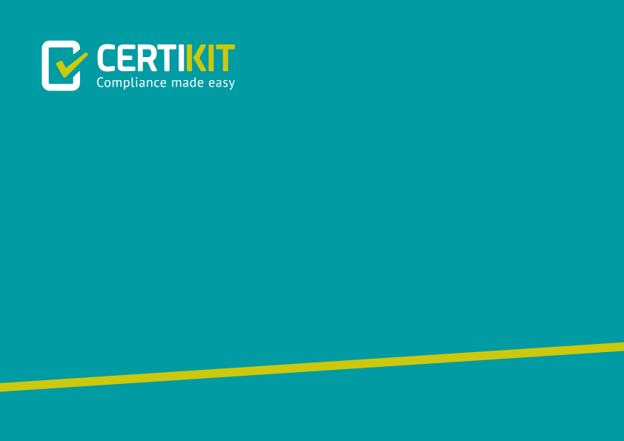
Business Continuity
Certification Readiness Checklist

ISO22301 Toolkit: Version 6
©CertiKit

Implementation guidance
The header page and this section, up to and including Disclaimer, must be removed from the final version of the document. For more details on replacing the logo, yellow highlighted text and certain generic terms, see the Completion Instructions document.

Purpose of this document
This document helps to assess when your BCMS is ready for certification.

Areas of the standard addressed
The following areas of the ISO22301 standard are addressed by this document:
- All

General guidance
There are a number of key building blocks to your BCMS that, if they are absent, are likely to result in a major nonconformity at audit time. Use this checklist to ensure that the important parts are in place before arranging your Stage One audit review. Of course, this checklist does not cover everything, and you should still use other tools, such as the Gap Assessment, to get a fuller picture of your BCMS and whether it meets the requirements of the standard.

Review frequency
The intention is that this document will only be used prior to certification.

Document fields
This document may contain fields which need to be updated with your own information, including a field for Organization Name that is linked to the custom document property “Organization Name”.
To update this field (and any others that may exist in this document):
- Update the custom document property “Organization Name” by clicking File > Info > Properties > Advanced Properties > Custom > Organization Name.
- Press Ctrl A on the keyboard to select all text in the document (or use Select, Select All via the Editing header on the Home tab).
- Press F9 on the keyboard to update all fields.
- When prompted, choose the option to just update TOC page numbers.
If you wish to permanently convert the fields in this document to text, for instance, so that they are no longer updateable, you will need to click into each occurrence of the field and press Ctrl Shift F9.
If you would like to make all fields in the document visible, go to File > Options > Advanced > Show document content > Field shading and set this to “Always”. This can be useful to check you have updated all fields correctly.
Further detail on the above procedure can be found in the toolkit Completion Instructions. This document also contains guidance on working with the toolkit documents with an Apple Mac, and in Google Docs/Sheets.

Copyright notice
Except for any specifically identified third-party works included, this document has been authored by CertiKit, and is ©CertiKit except as stated below. CertiKit is a company registered in England and Wales with company number 6432088.

Licence terms
This document is licensed on and subject to the standard licence terms of CertiKit, available on request, or by download from our website. All other rights are reserved. Unless you have purchased this product you only have an evaluation licence.
If this product was purchased, a full licence is granted to the person identified as the licensee in the relevant purchase order. The standard licence terms include special terms relating to any third-party copyright included in this document.

Disclaimer
Please Note: Your use of and reliance on this document template is at your sole risk. Document templates are intended to be used as a starting point only from which you will create your own document and to which you will apply all reasonable quality checks before use.
Therefore, please note that it is your responsibility to ensure that the content of any document you create that is based on our templates is correct and appropriate for your needs and complies with relevant laws in your country.
You should take all reasonable and proper legal and other professional advice before using this document.
CertiKit makes no claims, promises, or guarantees about the accuracy, completeness or adequacy of our document templates; assumes no duty of care to any person with respect its document templates or their contents; and expressly excludes and disclaims liability for any cost, expense, loss or damage suffered or incurred in reliance on our document templates, or in expectation of our document templates meeting your needs, including (without limitation) as a result of misstatements, errors and omissions in their contents.

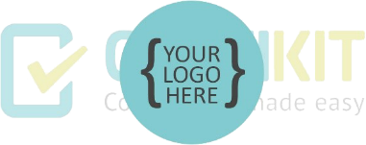
ISO22301 Certification
Readiness Checklist

Checklist details
[Note: this form covers the major points of readiness from a summary perspective only, highlighting those areas that, if they are not in place, may lead to
a major nonconformity at audit. For a full evaluation, use the gap assessment.]

Date: |  | Completed by: |  | Approved by:
Comments:

Checklist
ITEM | COMPLETED? | ACTION | BY WHOM | BY WHEN
1. Context and interested parties are defined | ☐
2. BCMS scope and objectives are defined | ☐
3. Roles and responsibilities are defined and people in place, with competence plans | ☐
4. There is a business continuity policy which has been approved and communicated | ☐
5. Monitoring and measurement of KPIs is in place | ☐
6. Business impact analysis and risk assessment have been carried out | ☐
7. There is a risk treatment plan in place | ☐
8. Business continuity plans and procedures are documented | ☐
9. Initial testing of business continuity plans and procedures has been carried out | ☐
10. At least one management review has been completed | ☐
11. At least one internal audit has been carried out | ☐
12. Nonconformities and improvements are being identified | ☐

